A Study of Probability Distributions, Mean, and Standard Deviation

Discrete Probabilities:
- Countable or finite.

Vocabulary
Random Variable:
A variable, 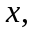 that has a value for each outcome of a procedure, that is determined by chance.

Probability Distribution:
A table that gives the probability for each value of a random variable.

Example
Rolling a die (probability distribution)
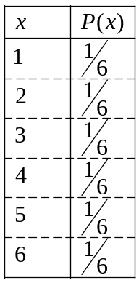

Discrete Random Variable:
A variable with a countable or finite number of values.

Continuous Random Variable:
A variable with an infinite number of possible values.
(usually a measurement)

Histogram from a probability distribution:
Horizontal: Values of random variable.
Vertical: Probability

Mean, Variance and Standard Deviation.
Mean: (expected value)
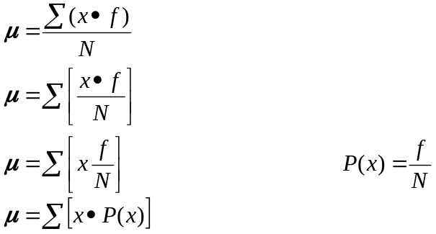

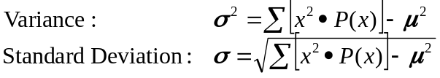

Example
Weighted Die:
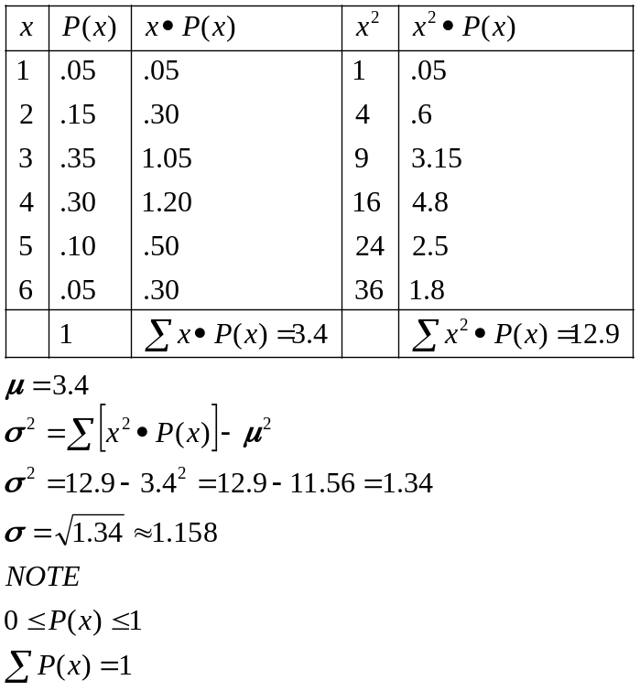
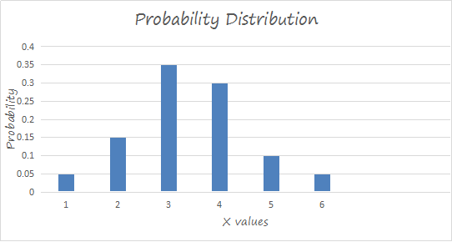
Usual vs. Unusual:
Values are unusual if they lie outside of:
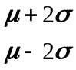 Plus or minus two standard deviations from the mean

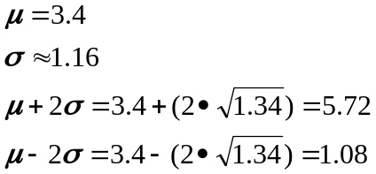

1 and 6 are unusual values on these weight dies, 2,3,4,5 are usual values.
Probability of less than 5% is consider it is considered unusual.

Example:
Flip a coin 1000 times. What is the probability of getting exactly 501 heads?
